Recycle Right
We are here to make communities cleaner and greener.
Every time you Recycle, it makes a difference.

Acceptable Plastics- We accept all plastic # 1-7.
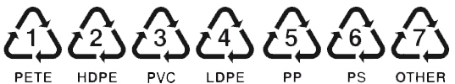

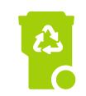
#1 Plastic- Soda and Water Bottles, Peanut Butter and other food jars. – PETE.
#2 Plastic- Milk Jugs, Juice Bottles, Yogurt Cups. –HDPE.
#3 Plastic- Household Cleaner Bottles, Liquid Detergent Bottles. –PVC.
#4 Plastic- Squeezable Bottles, Bread Bags, Plastic Wrapping.-LDPE.
#5 Plastic- Yogurt Cups, Ketchup Bottles, Syrup Bottles. –PP.
#6 Plastic- Meat Trays, Egg Cartons, Aspirin Bottles.-PS.
#7 Plastic- Three and Five Gallon Water Bottles. –OTHER.

What else can I recycle?  - Newspapers Including Inserts.  - Cardboard.  - Brown Paper Bags.  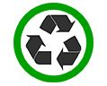  - Magazines, Catalogs, Phonebooks.  - Carrier Stock (Soda/Beer Carrying Cases.)  - Junk Mail/Envelopes.  - Paperback Books.  - Food Boxes.  - Paper.  - Beverage Cans-Aluminum Cans, Trays & Foils.  - Glass Jars. (Clear, Green & Brown.)  - Food Cans.  - Caps and lids for jars or bottles | What is NOT recyclable?  - Styrofoam.  - Holiday Wrapping Paper.  - Contaminated Paper.  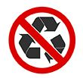  - Light Bulbs.  - Plastic Shopping Bags.  - Contaminated Pizza Boxes.  - Aerosol Cans.  - Ceramics & Pottery.  - Hypodermic Needles.  - Textiles.  - Electronics – Call Advanced for Pricing  - Yard Waste.
- When in doubt, throw your item in the garbage.
- Please be sure to rinse all plastic and metal containers to remove residue.
- If your area provides carts, all items must be placed in your cart to be collected.
- Please place recyclables loose in the cart with the blue lid

Questions? Please Call Advanced Disposal’s Customer Service at 888-688-4005.

